PRESS RELEASE:
ICONIC
16 Artists Including: Otis Jones, Alicia McCarthy, Tom Orr, Richard Serra, and Allison V. Smith
April 7 – May 22, 2021

Barry Whistler Gallery is proud to present, ICONIC, a group exhibition featuring works by Jonathan Cross, Linnea Glatt, Sam Gummelt, Luke Harnden, Bob Jackson, Otis Jones, Ellsworth Kelly, Matt Kleberg, Lawrence Lee, Alicia McCarthy, David McGee, Claes Oldenburg, Tom Orr, Richard Serra, Allison V. Smith, and Robert Wilhite. Pieces included in this exhibition will focus on seminal imagery from these epochal artists.

DAVID McGEE
(Houston, Texas)
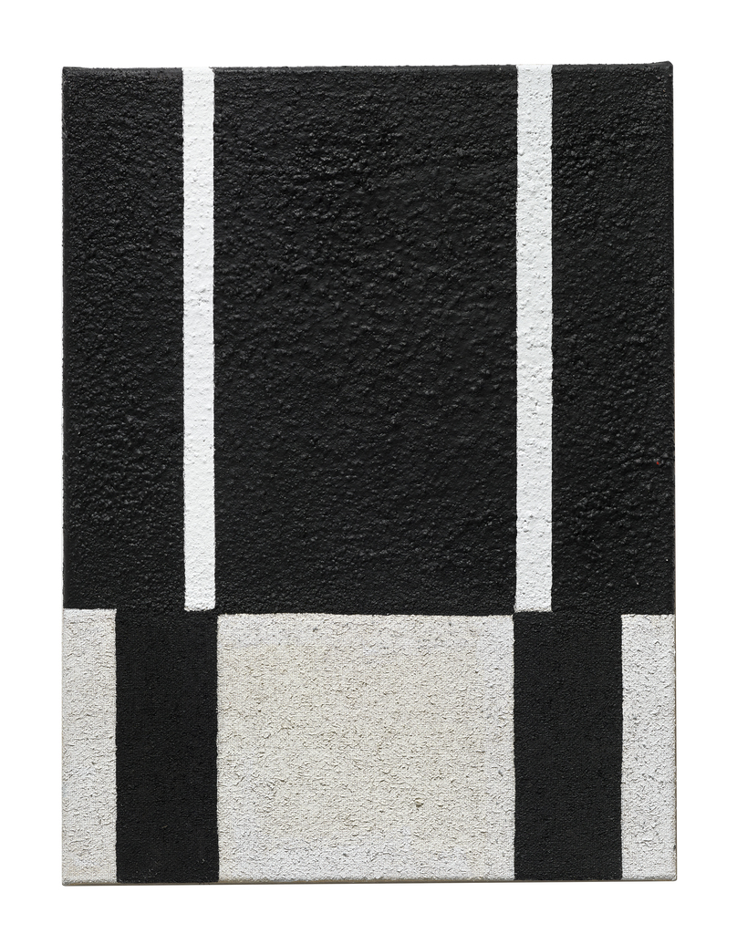
ICONIC will showcase a 30-panel David McGee piece on the gallery’s two largest walls spanning nearly 68 feet. Felicia Johnson describes, “Black Paintings from a Black man living in America. Black life, Black politics, Black love. Most of the pieces in this show come from McGee's ongoing series Urban Dread, white and black treatises on the stark realities of life. The paintings themselves consist of oil, wax and sand on burlap. Their rough, gritty texture represents graffiti, white flight and (sub)urban angst. Street life, nappy hair, the systemic condemnation of technology. McGee plays in this role the conductor of a ghetto opera using modernist tropes. He places each painting side by side, forcing the audience to move through the series, experiencing these images as chapters in a book.”

JONATHAN CROSS
(Pasadena, California)

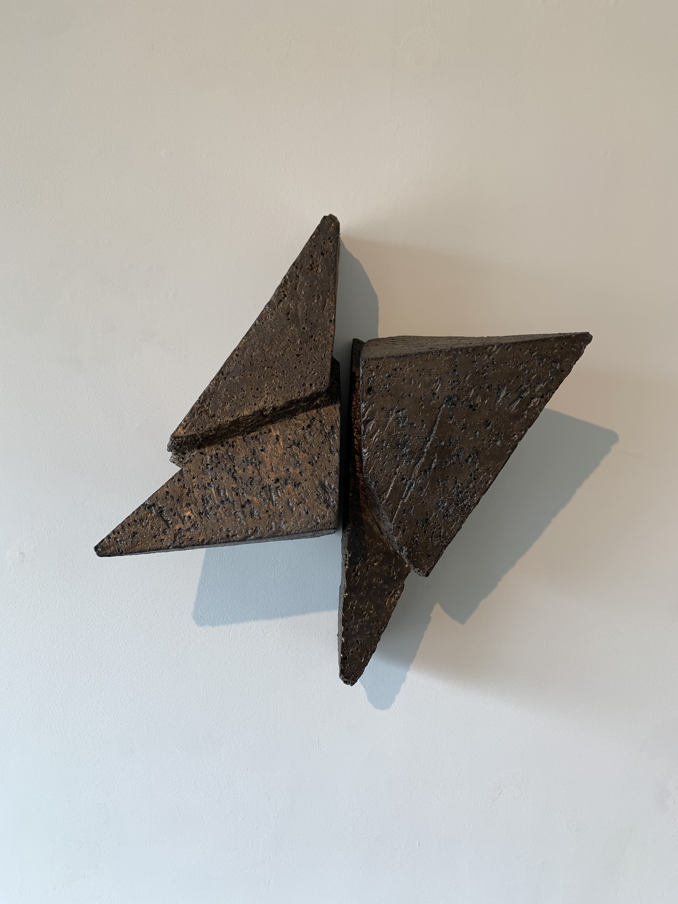

Jonathan Cross will feature four new wall hung stoneware works which are wood fired in his desert kiln outside of Joshua Tree, California. Cross explains, “Clay is an important material for me because of its transformative potential. It can be open, compressed, wet, hard, even crystalized. Sedimentary clay is derived from the decomposition of stone, by adding water it is transformed into a malleable material open to many actions. I use the malleable clay and start each piece by compressing it into a solid mass. From this mass of semi-wet clay, a form is slowly excavated, carved, discovered.”

ALICIA McCARTHY
(Oakland, California)

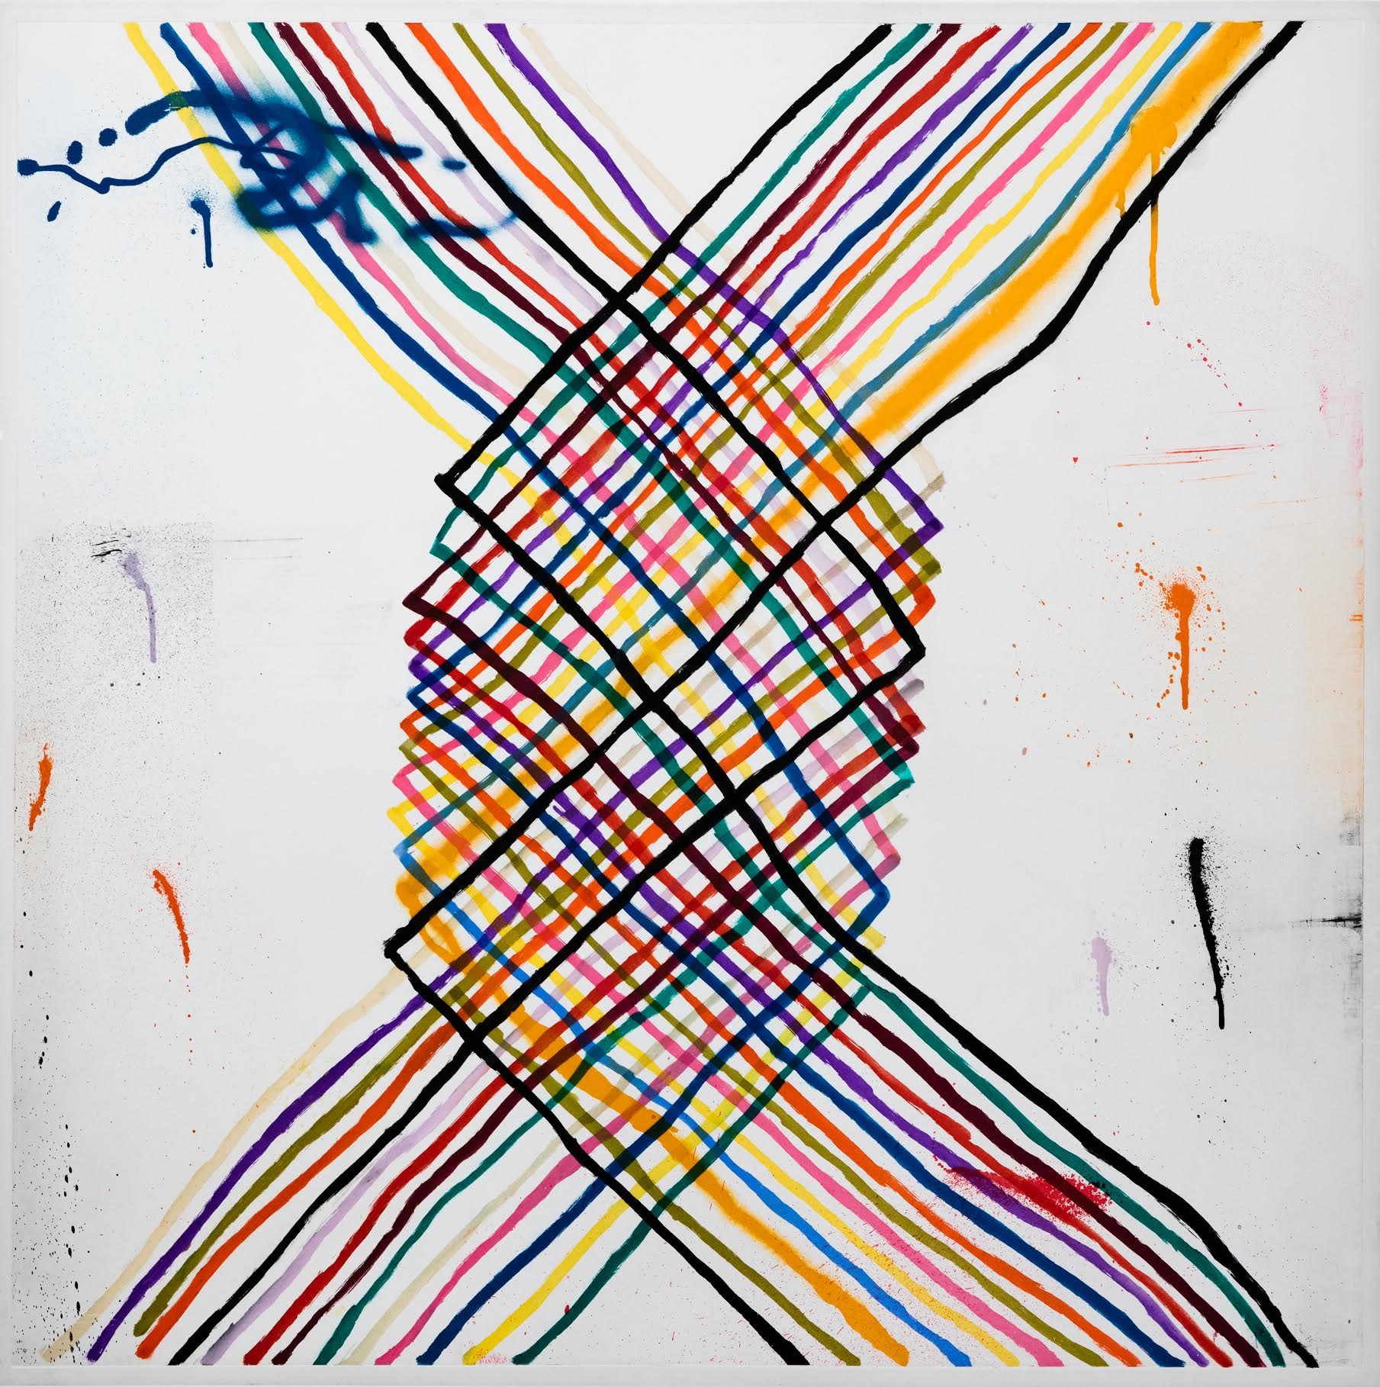

Alicia McCarthy lives and works in Oakland, California. This exhibtion will include a large punchy color-patterned print, a consistent imagery in the artist’s work. This will be McCarthy’s first inclusion in a group show at Barry Whistler Gallery—she is represented by Jack Hanley Gallery in New York.

TOM ORR
(Dallas, Texas)

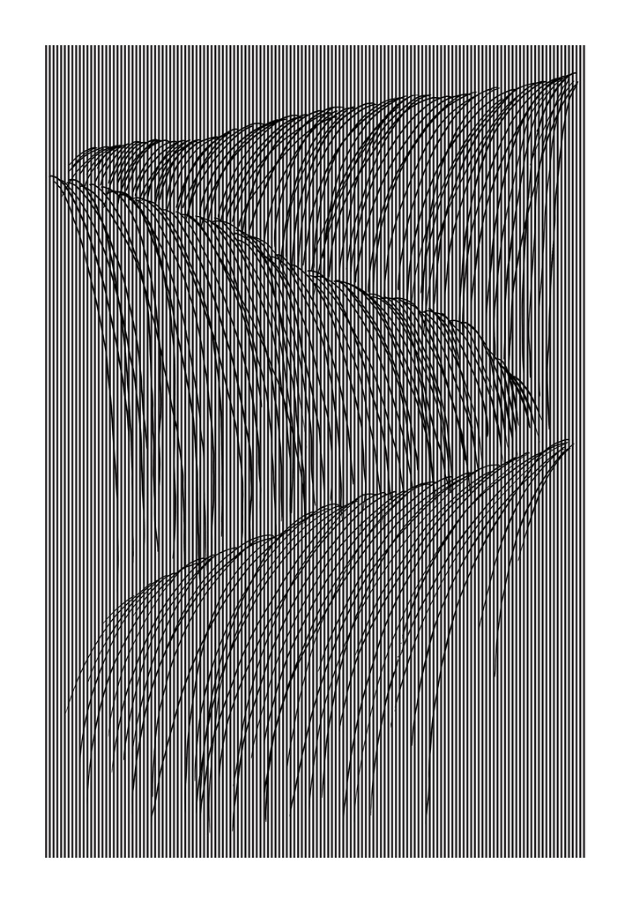

Tom Orr persists in his examination of waterfalls seen in his two prints included in the show, Waterfall 2 and 4. Both works were included in Orr’s most recent show in 2019 which was comprised entirely of waterfalls. The pieces, with archival pigment printed on a thick heavy paper, are displayed in open maple frames. The mesmerizing prints create aberrations in the viewers eyes.

RICHARD SERRA

Richard Serra, well known worldwide for his monumental metal sculptures has now garnered an equally impressive track record with his large scale prints. Typically he is pushing the medium to its limits, along with Gemini G.E.L. he developed a unique approach manipulating oil stick providing him with his desired texture, and conveying a sense of weight. The work included here is from a group of related one-color-etchings completed at Gemini G.E.L. Los Angeles in 2009.

LAWRENCE LEE
(Dallas, Texas)

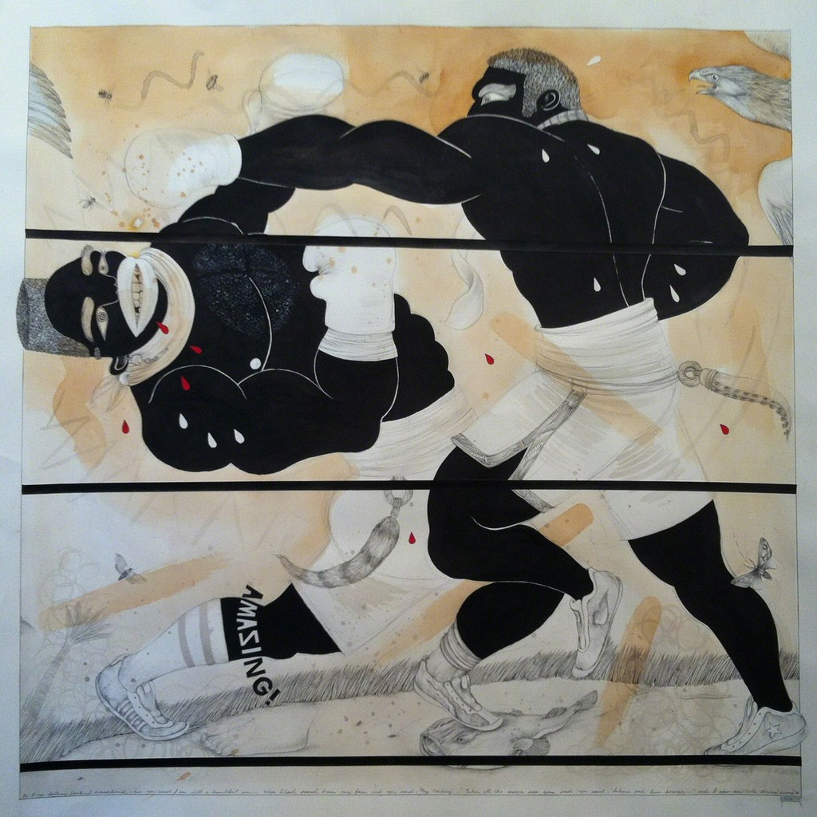

ICONIC will include three drawings by Lawrence Lee that continues to explore a series he has been intrigued by the last several years. Lee explains:
“When I made these drawings, I imagined a giant field that was thousands of square miles in size. I imagined that fighters were placed in the field like windup toys in a sandbox. They engaged in combat whenever they happened upon another fighter or some violent creature. The one left standing continues his wandering and on it goes. It feels like a relevant metaphor for the world in some way. It is a world waiting for a hero to emerge from the programmed monotony. It is a world sleeping and waiting to be awakened. Whether that hero takes the form of a boxer or a something else entirely is the question I'd like to explore.”

