PRESS RELEASE:

A Selection of Drawings by Andrea Rosenberg

December 5 –January 16, 2021

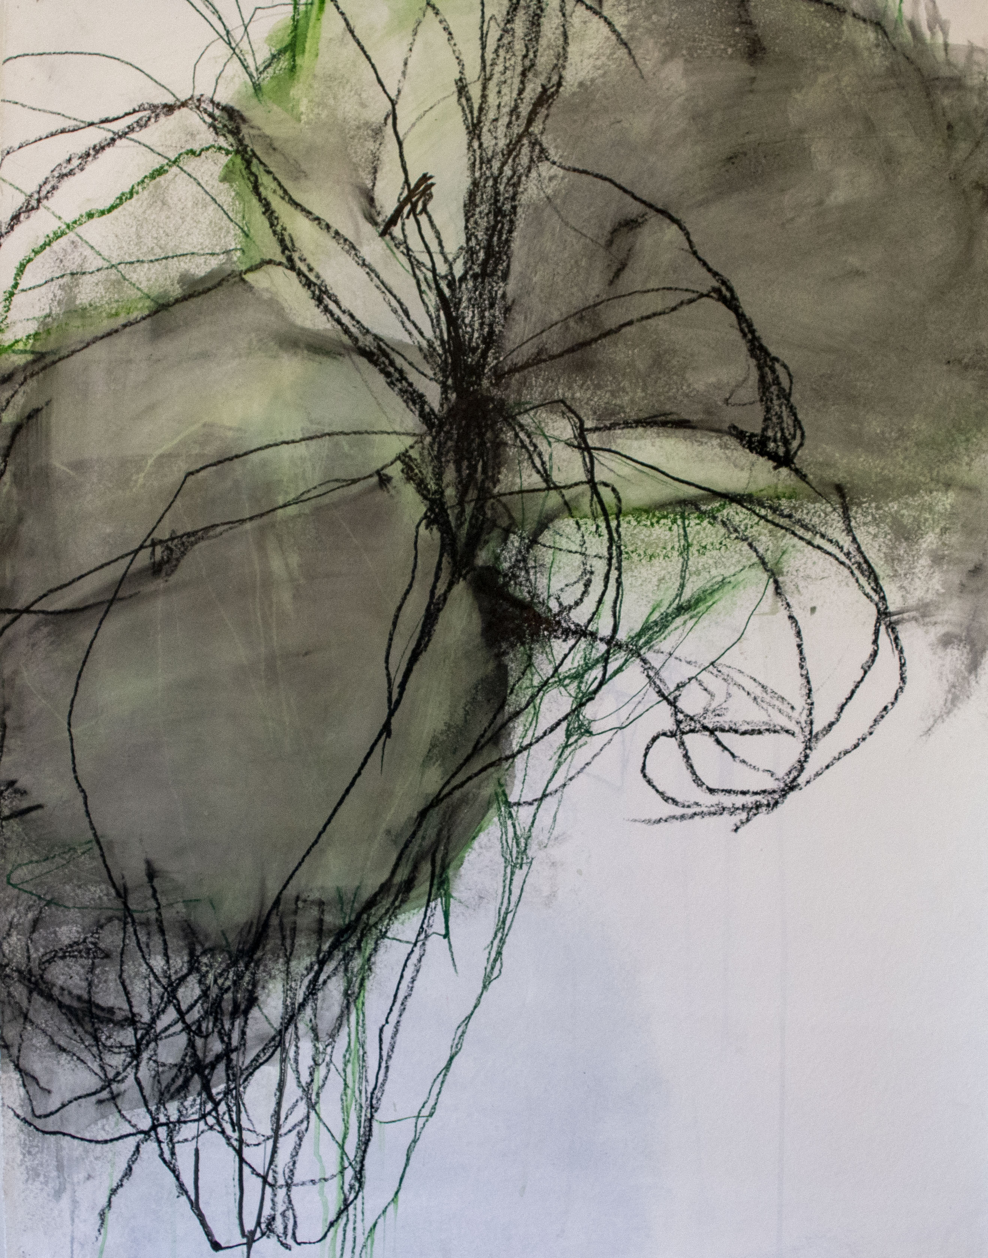

ANDREA ROSENBERG
Untitled 50, 2020
Mixed media on paper
47 x 35 inches

Barry Whistler Gallery is pleased to present A Selection of Drawings by Andrea Rosenberg. The exhibition runs December 5 – January 16, 2021. The gallery is currently open by appointment only.

This exhibition marks Rosenberg’s sixth solo show with Barry Whistler Gallery since 2008. The exhibition is comprised of over a dozen large scale works and eleven small scale works on paper.

In ANDREA ROSENBERG: The Living Line, Frances Colpritt describes, “Rosenberg’s working process is thoroughly improvisational, incorporating a variety of tools and mediums, such as pencils, charcoal, crayons, and watercolors. Without any preconceptions or preparatory studies, the drawings emerge spontaneously, spawned only by her past experiences and the longevity of her practice. Energy, she told me, is the source and meaning of her drawn forms.”

The artist’s work is in the following museum collections: The Brooklyn Museum; Dallas Museum of Art; Museum of Fine Arts, Houston; and The Modern Art Museum of Fort Worth.

Corporate collections include American Airlines; DFW Airport; George W. Bush Presidential Center, Dallas; Hall Financial, Frisco Texas; and others.

Rosenberg lives and works in Dallas. She received her M.A. (1971) from Case Western Reserve University in Cleveland, Ohio. She studied at the Art Students League of New York from 1962-1966.

Additional information and images available upon request.

