PRESS RELEASE:
JAY SHINN
New Drawings

February 29 - April 4, 2020
Opening reception: Saturday, February 29th
6-8PM

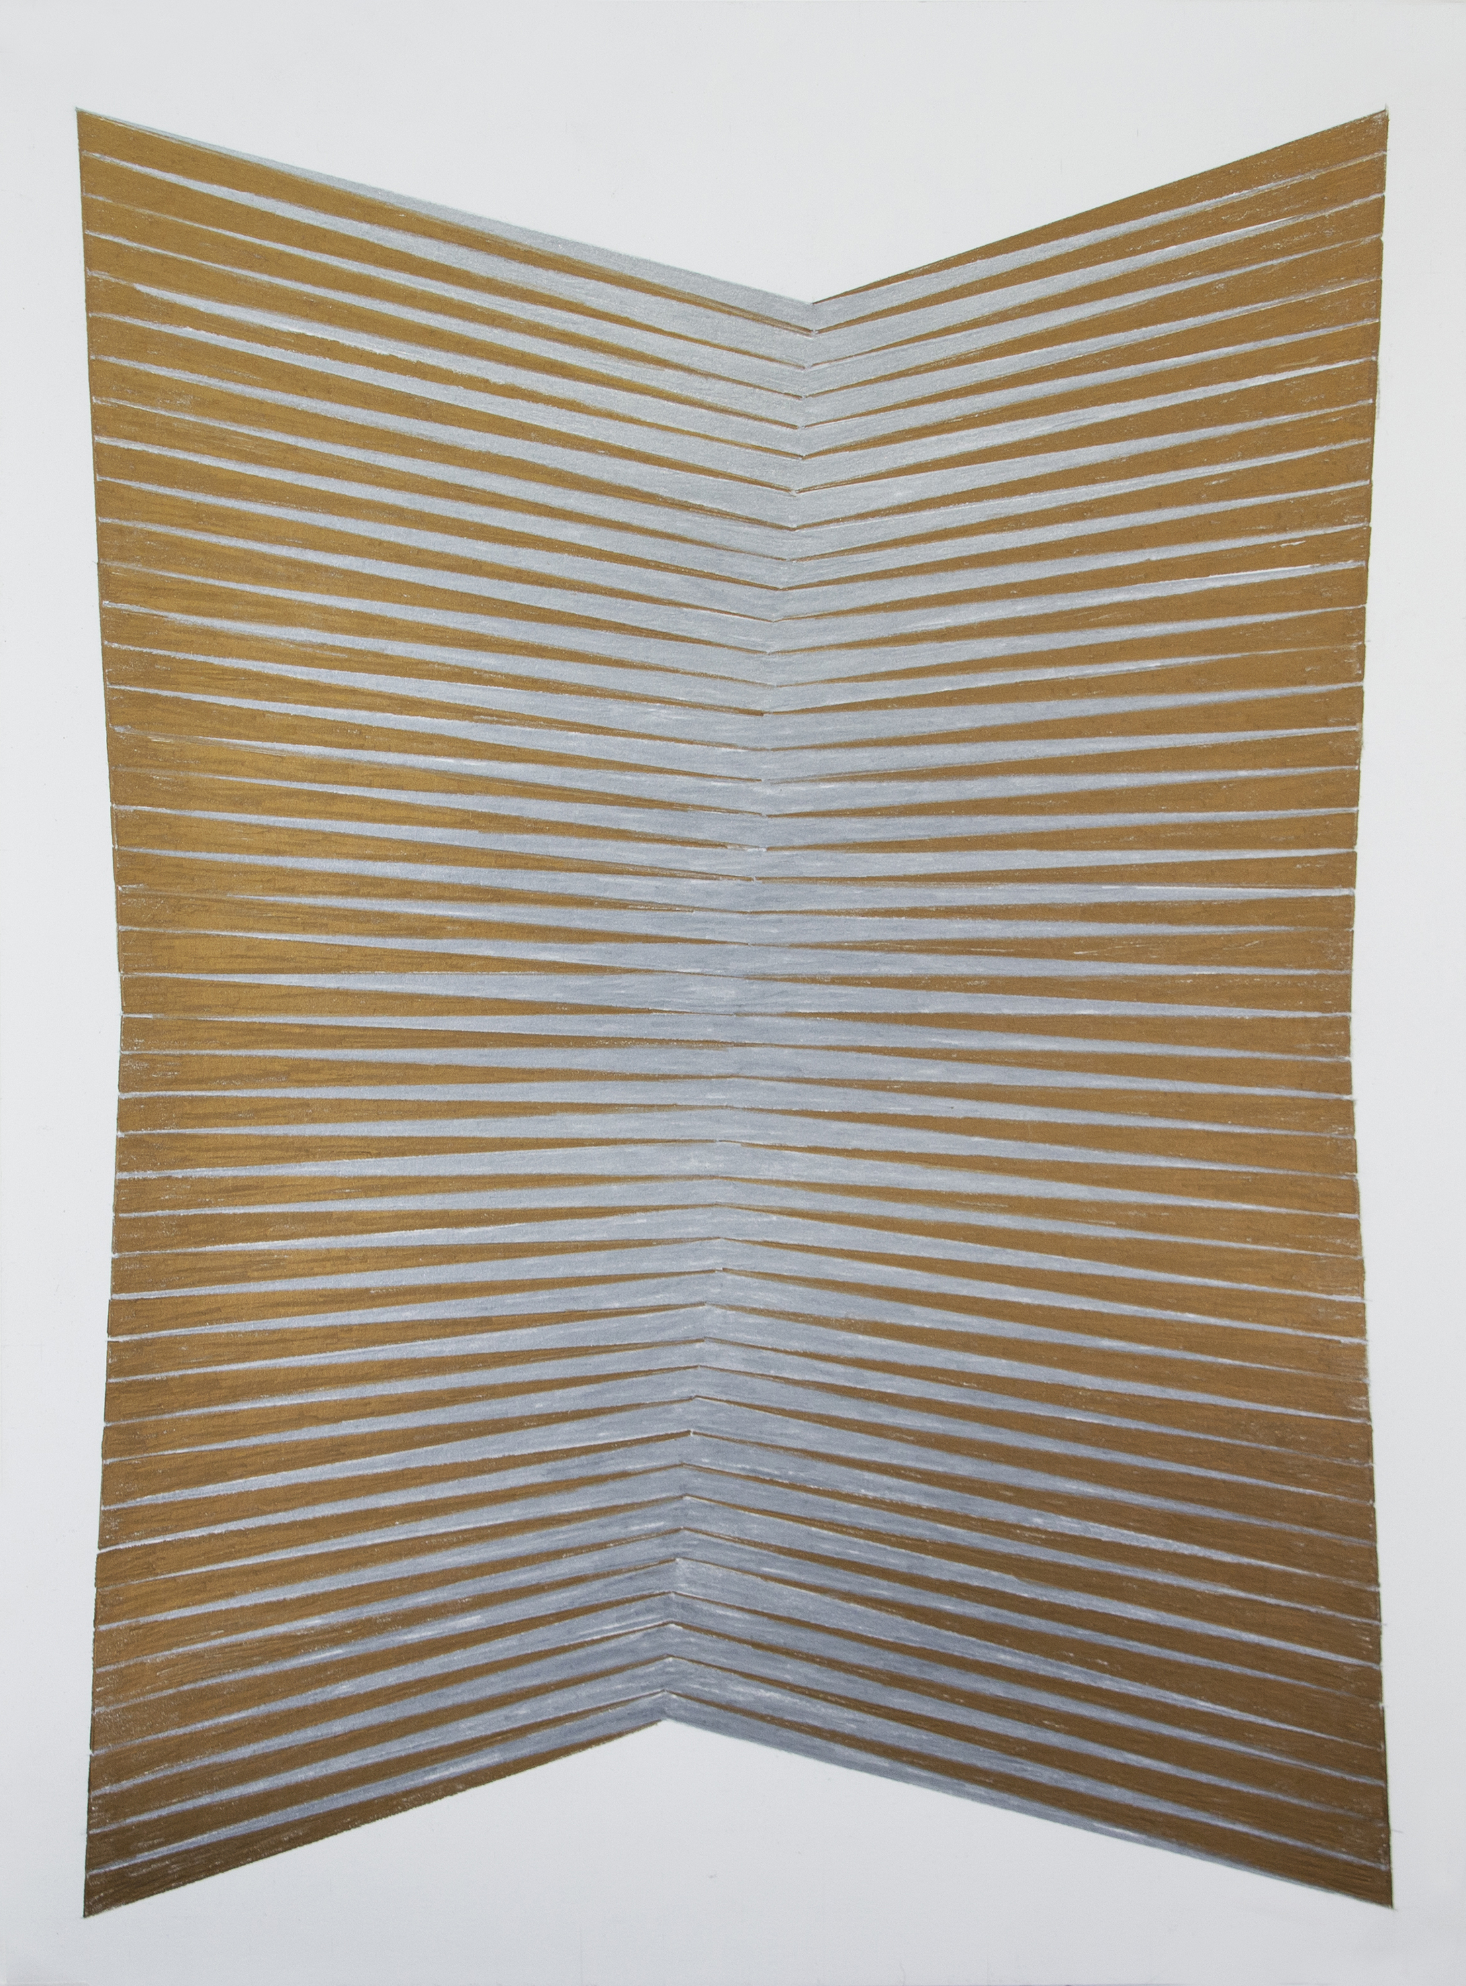
Jay Shinn
Dyad #9, 2019
Colored pencil on paper
24 x 18 inches

Jay Shinn, an interdisciplinary artist born in Magnolia, Arkansas, lives in Dallas-working out of both Dallas and New York.

Shinn is a contemporary Op artist that chiefly creates two-dimensional work that appear three-dimensional. He often employs the use of line, light, and shadow to create geometric volume within work. He transcends dimensions with premeditated precision creating a metamorphis of shape, light, and color.

Shinn’s work is often site-specific but ranges from works on paper (featured here), paintings, wall-installation, and sculptures. Through his practice, he has successfully been able to push the boundaries of opticality, relational composition, and illusorily constructed shapes.

Drawings explores illusions through its’ two-dimensional works on paper. Shinn states, “These drawings each began as a simple and somewhat vague idea. The image merged from a grid first drawn with pencil. Various forms evolved as a direct response to the size and shape of the paper. Boundaries were self-imposed from drawing to drawing as guidelines. These given parameters then led the series of decisions towards the final outcomes, driving my curiosity towards making the common uncommon.”

Shinn received his BFA from the Kansas City Art Institute and is an alumnus of the Skowhegan School of Painting and Sculpture. Recent residencies include Yaddo and Art Omi both in New York, the Takt Residency in Berlin, Germany, and this past spring at the Crow Collection of Asian Art. Recent exhibitions include Louise Alexander Gallery, Porto Cervo, Italy; Galerie Jordan Seydoux, Berlin, Germany; Barbara Davis Gallery, Houston; Theodore Art, NYC; Leila Heller Gallery, NYC; Knoerle & Baettig, Winterthur, Switzerland; and the University of Colorado at Colorado Springs. His work is in numerous public and private collections including Houston Intercontinental Airport, DFW Airport, Hobby Airport in Houston, Tom Ford in New York, W Hotels, and Microsoft Corporation in Washington.

“For me as an artist, drawing is a necessity. Not only does it teach me to see, it also allows me to channel my ideas by turning them into physical images or forms.” Drawing is one of he most direct means to move an idea forward.

Additional information and images available upon request.

