PRESS RELEASE:
JOHN-PAUL PHILIPPE
EYE-LANDS
&
PETER LIGON
NEW PAINTINGS
December 7 – January 11, 2020

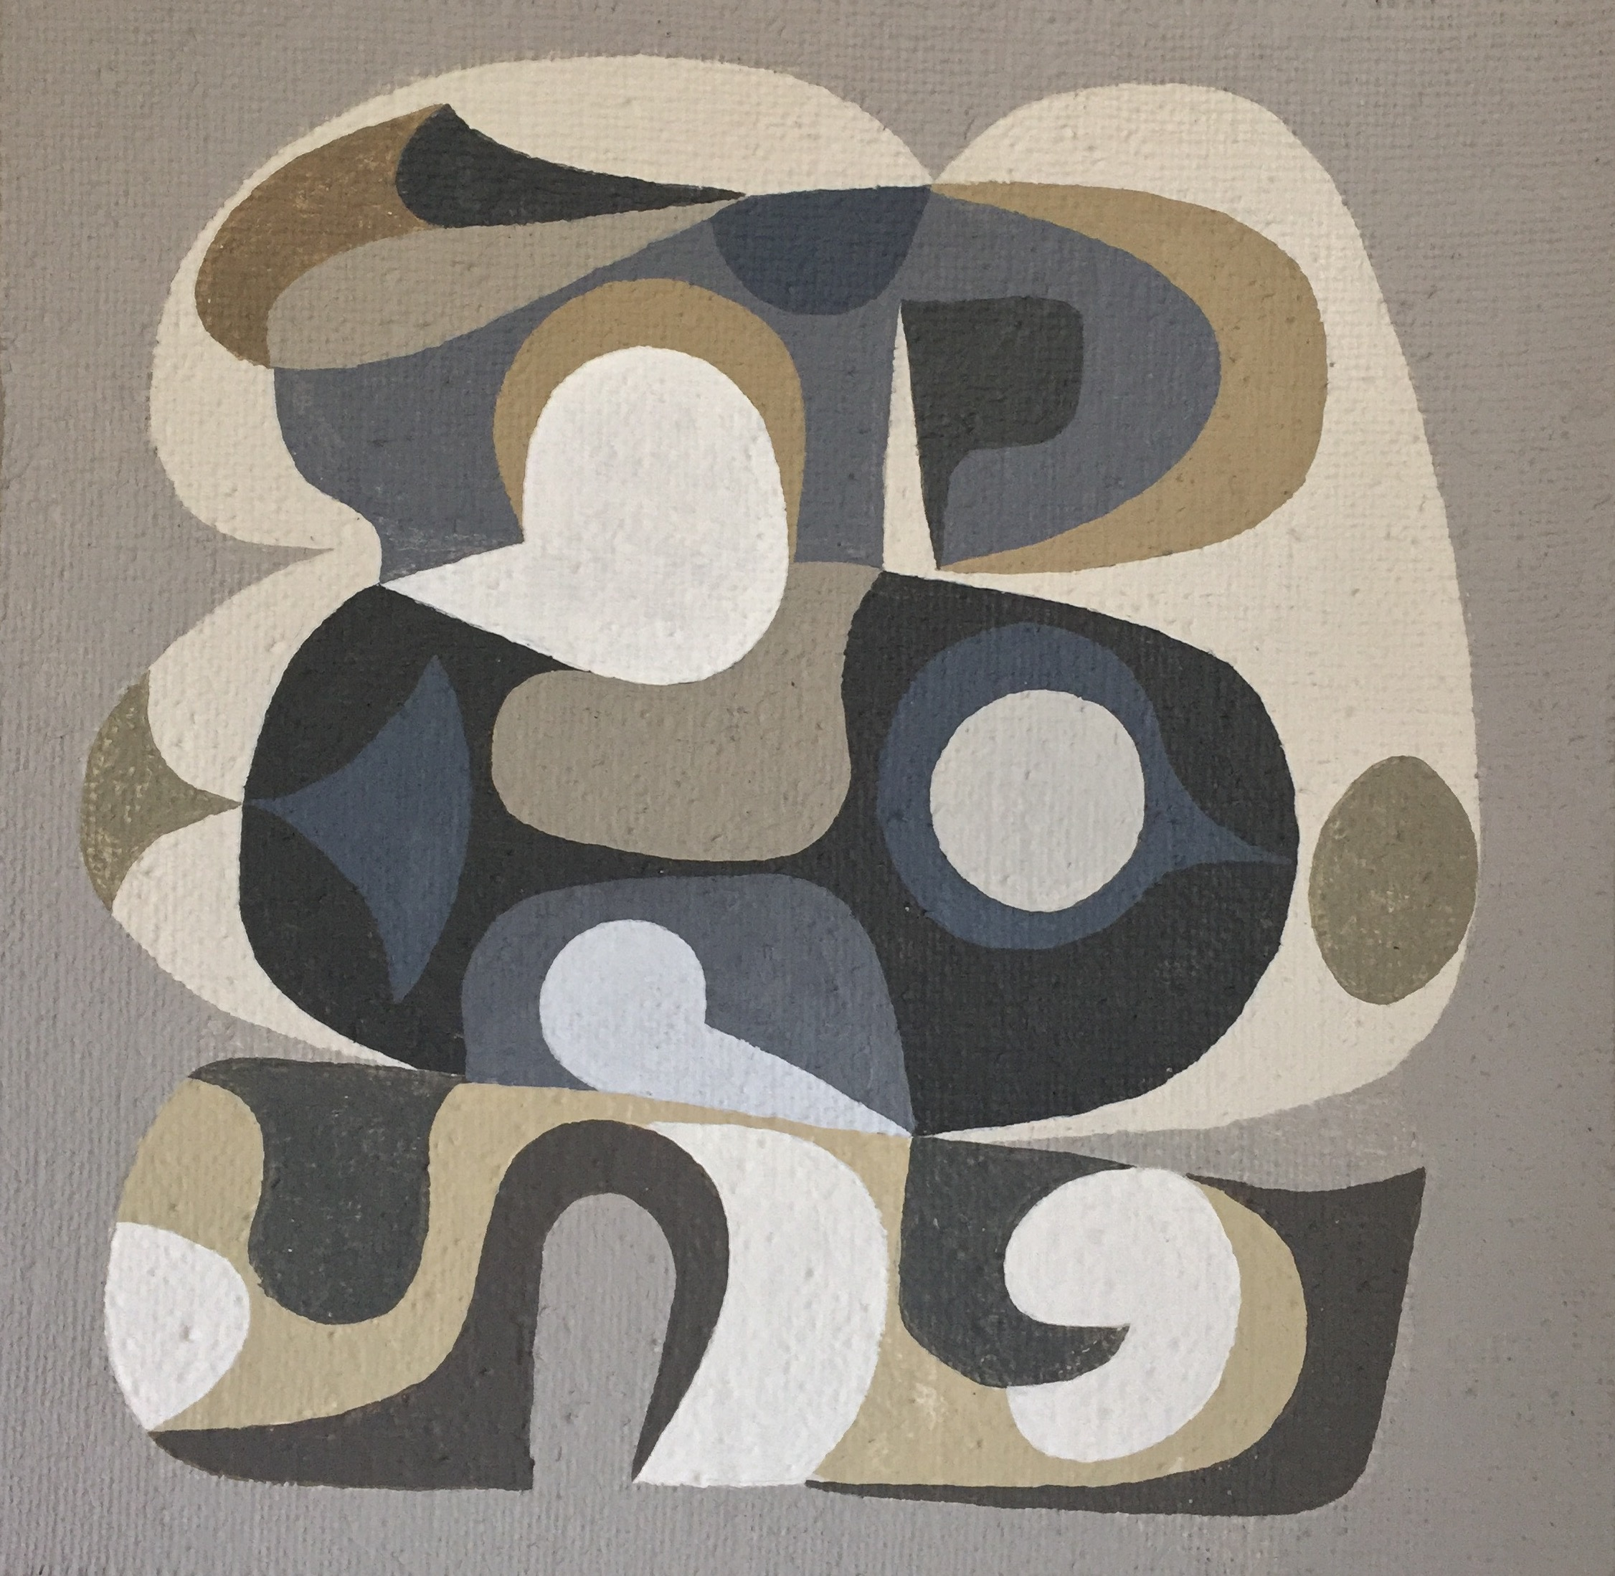
John-Paul Philippe
Eye-Lands #3, 2019
Emulsified gouache on hessian mounted on panel
12 x 12 inches

Barry Whistler Gallery is pleased to present John-Paul Philippe’s Eye-Lands and Peter Ligon’s New Paintings. The opening reception for both exhibitions will take place on Saturday, December 7th from 6-8pm.

John-Paul Philippe, a painter and designer based in Sharon, Connecticut, was born and raised in Oklahoma. He earned his BFA in Art & Art History from the University of Oklahoma in 1978. Philippe spent 23 years living in London as a painter. His large body of work ranges from architectural and furniture design to murals, sculpture, as well as, paintings on canvas and linen. This large expanse of medium led to Philippe’s position as the lead creative artist at the forefront of the Barneys New York store concept and interior art throughout the United States and Japan. Recent endeavors include large-scale metal architectural partitions, commissioned for public and private collections in addition to gallery exhibitions.

In Dallas, The NorthPark Barney’s location (closed in 2012) predominately featured one of the artist’s large-scale architectural works on its façade.

This solo exhibition, his second solo show at BWG, will bring John-Paul to Dallas for a two-week period. During that time he will work diligently on the walls of the gallery to complete a 30-foot mural. Large and small canvases related to the mural will accompany the exhibition. His work most often resembles the clouds and hills from his original home in Oklahoma.

Additionally, many of the small works in the exhibition use motifs derived from nature on his property in Connecticut. Philippe recalls a recent experience, “On a bitterly cold day in January of this year I was walking across the ice of a frozen pond near my Connecticut cabin. I wanted to reach a small island but instead, the ice broke beneath me and I ended up sinking into the cold muck of the bottom…flat on my back. I obviously escaped, though narrowly, and after a period of recovery I produced these works depicting that unreachable island…now covered in symbolic and reoccurring motifs from my past.”

John-Paul Philippe’s architectural design can be seen around the world, from a restaurant in Japan to a chapel in the Dominican Republic, to Lehmann Maupin Gallery’s Lower East Side location.

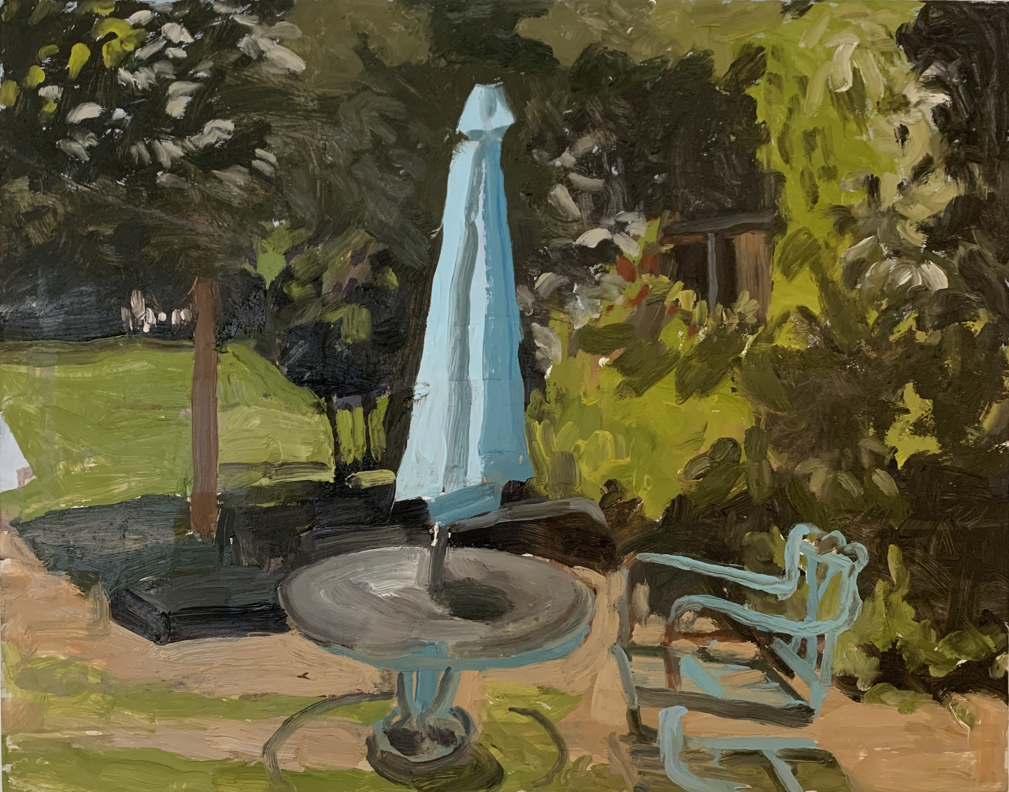

Peter Ligon
Blue Umbrella, 2019
Oil on panel
11 x 14 inches

Living and working in Dallas, Peter Ligon received his BFA from the University of North Texas and an MFA from the Meadows School of the Arts at SMU.

He is a founding resident of the artist run studio cooperative Shamrock Hotel Studios in Dallas. He currently teaches drawing, art appreciation, printmaking, and painting variously at University of Texas at Dallas, Eastfield Community College, and SMU.

For the upcoming exhibition, Ligon will present a small grouping of his iconic En Plein Air paintings. He can most often be found chasing the light and painting from the cab of his truck, typically accomplishing his small paintings in one sitting. He has brought this approach to the landscape of Texas, Maine, and New Mexico.

Peter Ligon works in a range of media including oil, watercolor, ink and ink wash, monotype, and intaglio printmaking. His sources, often architectural, are predominately observational. Ligon says, “My operative motives include the implementation of accidental or predetermined strategies in the interpretation of color and spatial relationships of the landscape and built environment.”

Additional information and images available upon request.

